IMU Dataset SimCLR Supervised Results
Below are the results for the experiments running a trained SimCLR encoder (via unsupervised learning), and gauging its performance across various downstream supervised tasks.
This results file is split by task (via “ClassNum”, then using linear/MLP probe, and shows the performance across various sizes)

Task 1: ClassNum 2
Binary Classification: Are you touching your face?

Linear Probe
Size: 3
Train | Validation | Test
Accuracy: 0.8320  Loss: 0.3786 | Accuracy: 0.7726  Loss: 0.4886 | Accuracy: 0.7668  Loss: 0.4769

Precision | Recall | F1 Score
0.6185 | 0.7620 | 0.6826

Confusion Matrix:
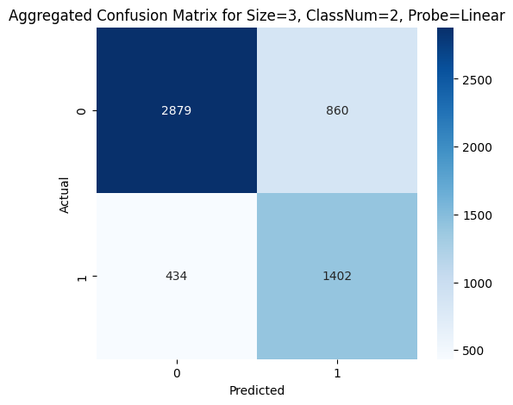

Size: 5
Train | Validation | Test
Accuracy: 0.8265  Loss: 0.3905 | Accuracy: 0.7609  Loss: 0.4827 | Accuracy: 0.7685  Loss: 0.4693

Precision | Recall | F1 Score
0.6232 | 0.7538 | 0.6819

Confusion Matrix:
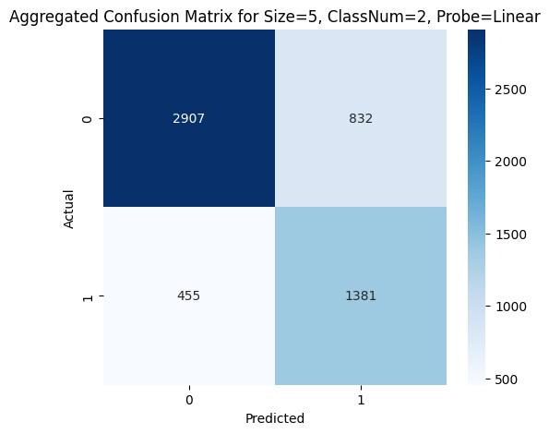

Size: 10
Train | Validation | Test
Accuracy: 0.8352  Loss: 0.3715 | Accuracy: 0.7749  Loss: 0.4801 | Accuracy: 0.7778  Loss: 0.4637

Precision | Recall | F1 Score
0.6333 | 0.7761 | 0.6970

Confusion Matrix:
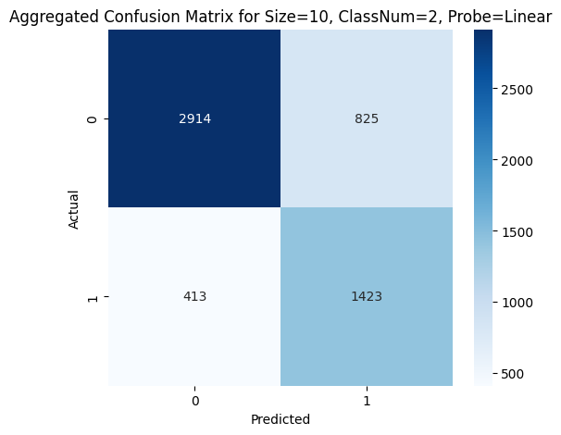

Size: 15
Train | Validation | Test
Accuracy: 0.8326  Loss: 0.3703 | Accuracy: 0.7870  Loss: 0.4532 | Accuracy: 0.7892  Loss: 0.4352

Precision | Recall | F1 Score
0.6720 | 0.7048 | 0.6877

Confusion Matrix:
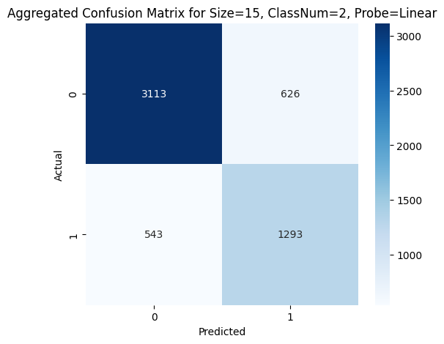

Size: 20
Train | Validation | Test
Accuracy: 0.8401  Loss: 0.3564 | Accuracy: 0.7911  Loss: 0.4441 | Accuracy: 0.7921  Loss: 0.4292

Precision | Recall | F1 Score
0.6971 | 0.6555 | 0.6751

Confusion Matrix:
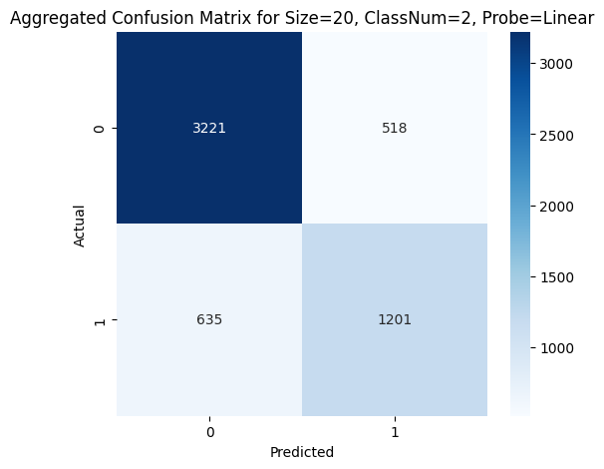

MLP Probe
Size: 3
Train | Validation | Test
Accuracy: 1.0000  Loss: 0.0031 | Accuracy: 0.8017  Loss: 0.8019 | Accuracy: 0.8091  Loss: 0.7487

Precision | Recall | F1 Score
0.6775 | 0.8083 | 0.7366

Confusion Matrix:
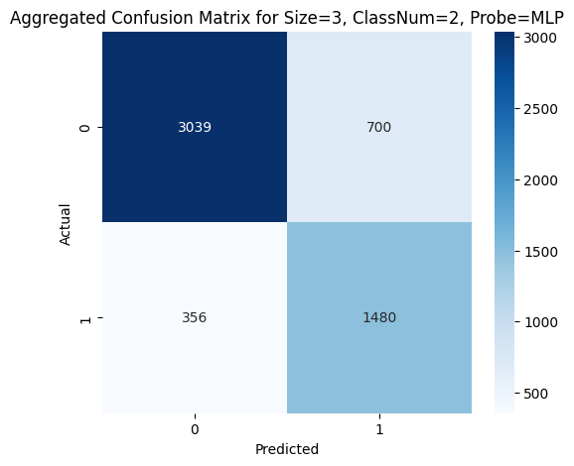

Size: 5
Train | Validation | Test
Accuracy: 1.0000  Loss: 0.0025 | Accuracy: 0.8041  Loss: 0.8555 | Accuracy: 0.8087  Loss: 0.7991

Precision | Recall | F1 Score
0.6779 | 0.8039 | 0.7351

Confusion Matrix:
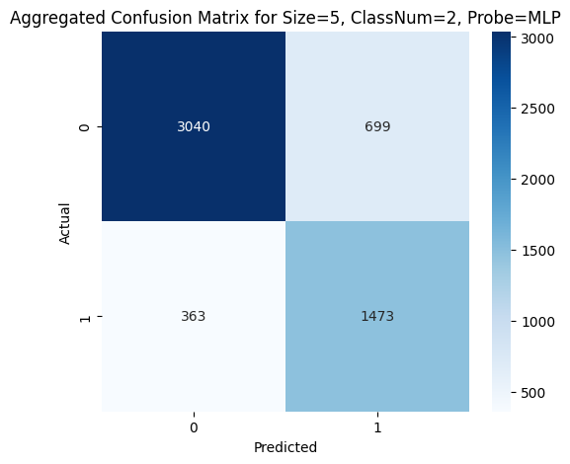

Size: 10
Train | Validation | Test
Accuracy: 1.0000  Loss: 0.0019 | Accuracy: 0.8206  Loss: 0.9075 | Accuracy: 0.8262  Loss: 0.8307

Precision | Recall | F1 Score
0.7021 | 0.8251 | 0.7580

Confusion Matrix:
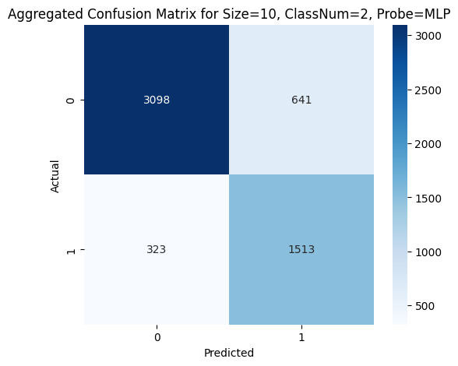

Size: 15
Train | Validation | Test
Accuracy: 1.0000  Loss: 0.0016 | Accuracy: 0.8260  Loss: 0.9053 | Accuracy: 0.8314  Loss: 0.8249

Precision | Recall | F1 Score
0.7261 | 0.7894 | 0.7557

Confusion Matrix:
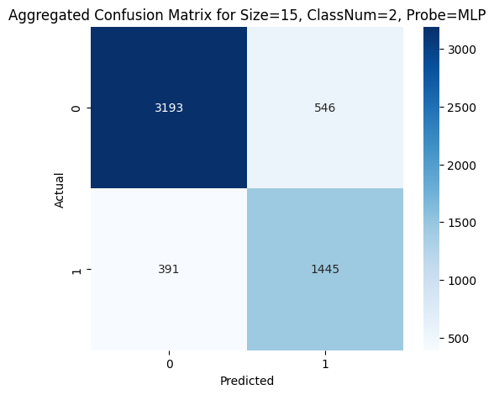

Size: 20
Train | Validation | Test
Accuracy: 1.0000  Loss: 0.0014 | Accuracy: 0.8327  Loss: 0.8750 | Accuracy: 0.8395  Loss: 0.8304

Precision | Recall | F1 Score
0.7563 | 0.7607 | 0.7579

Confusion Matrix:
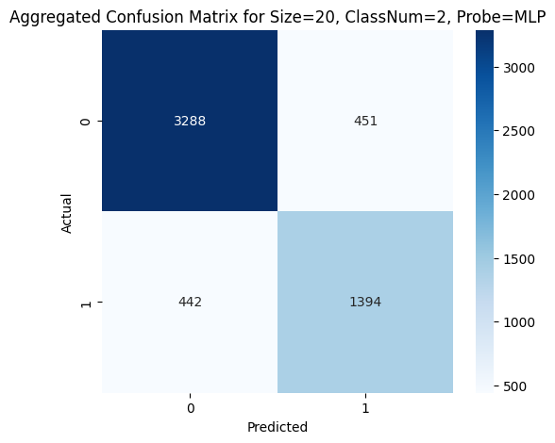

Task 2: ClassNum 3
Touch type classification: Brief touch vs. Continuous touch vs. No touch

Linear Probe
Size: 3
Train | Validation | Test
Accuracy: 0.8529  Loss: 0.3846 | Accuracy: 0.7569  Loss: 0.5723 | Accuracy: 0.7530  Loss: 0.5847

Precision | Recall | (Macro) F1 Score
0.7516 | 0.7508 | 0.7498

Confusion Matrix:
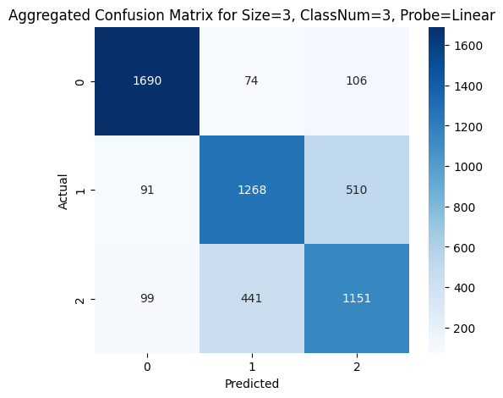

Size: 5
Train | Validation | Test
Accuracy: 0.8447  Loss: 0.3916 | Accuracy: 0.7695  Loss: 0.5438 | Accuracy: 0.7639  Loss: 0.5530

Precision | Recall | (Macro) F1 Score
0.7647 | 0.7620 | 0.7614

Confusion Matrix:
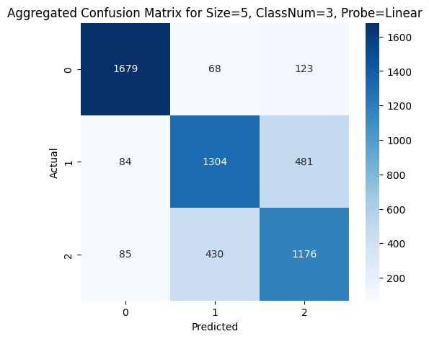

Size: 10
Train | Validation | Test
Accuracy: 0.8440  Loss: 0.3974 | Accuracy: 0.7781  Loss: 0.5107 | Accuracy: 0.7761  Loss: 0.5233

Precision | Recall | (Macro) F1 Score
0.7762 | 0.7739 | 0.7728

Confusion Matrix:
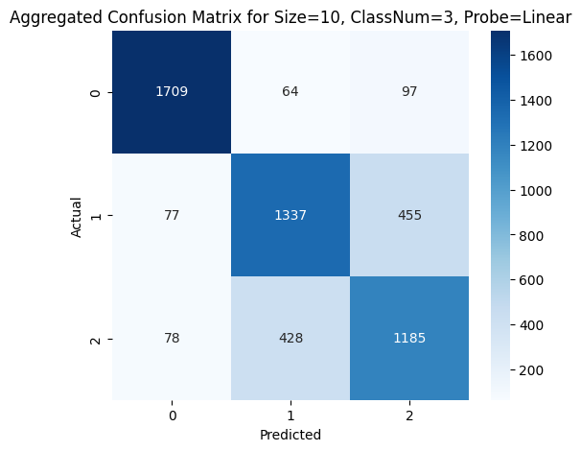

Size: 15
Train | Validation | Test
Accuracy: 0.8399  Loss: 0.3862 | Accuracy: 0.7851  Loss: 0.4938 | Accuracy: 0.7802  Loss: 0.5144

Precision | Recall | (Macro) F1 Score
0.7784 | 0.7777 | 0.7755

Confusion Matrix: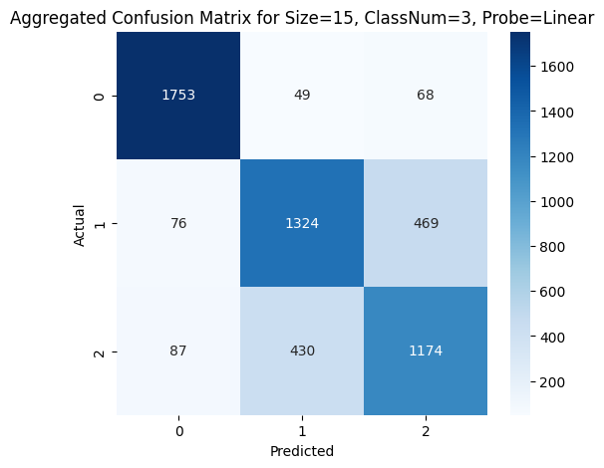

Size: 20
Train | Validation | Test
Accuracy: 0.8413  Loss: 0.3930 | Accuracy: 0.7890  Loss: 0.4938 | Accuracy: 0.7803  Loss: 0.5105

Precision | Recall | (Macro) F1 Score
0.7787 | 0.7777 | 0.7763

Confusion Matrix:
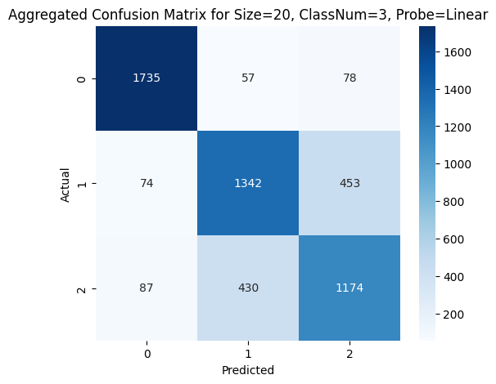

MLP Probe
Size: 3
Train | Validation | Test
Accuracy: 1.0000  Loss: 0.0032 | Accuracy: 0.7835  Loss: 0.8543 | Accuracy: 0.7817  Loss: 0.8868

Precision | Recall | (Macro) F1 Score
0.7803 | 0.7800 | 0.7781

Confusion Matrix:
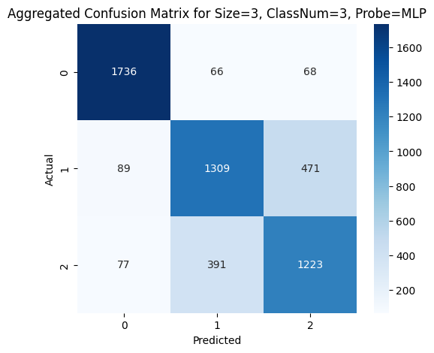

Size: 5
Train | Validation | Test
Accuracy: 1.0000  Loss: 0.0029 | Accuracy: 0.7875  Loss: 0.8915 | Accuracy: 0.7970  Loss: 0.9119

Precision | Recall | (Macro) F1 Score
0.7963 | 0.7955 | 0.7936

Confusion Matrix:
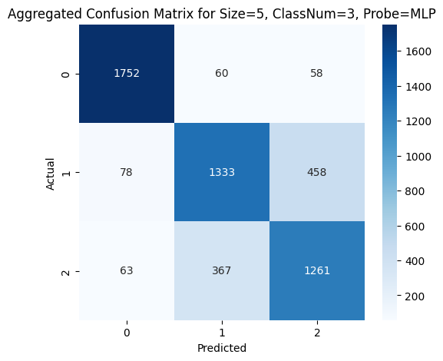

Size: 10
Train | Validation | Test
Accuracy: 1.0000  Loss: 0.0019 | Accuracy: 0.8012  Loss: 0.9317 | Accuracy: 0.8004  Loss: 0.9514

Precision | Recall | (Macro) F1 Score
0.7990 | 0.7989 | 0.7975

Confusion Matrix:
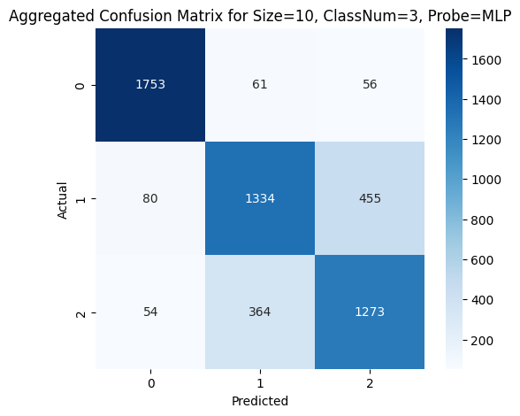

Size: 15
Train | Validation | Test
Accuracy: 1.0000  Loss: 0.0016 | Accuracy: 0.8154  Loss: 0.9432 | Accuracy: 0.8104  Loss: 0.9797

Precision | Recall | (Macro) F1 Score
0.8090 | 0.8090 | 0.8079

Confusion Matrix: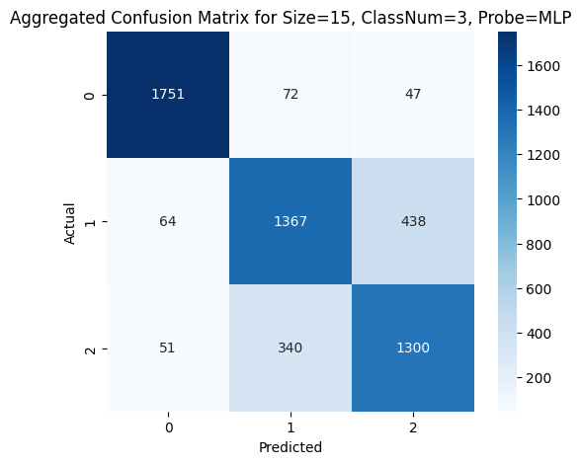

Size: 20
Train | Validation | Test
Accuracy: 1.0000  Loss: 0.0014 | Accuracy: 0.8179  Loss: 0.9435 | Accuracy: 0.8152  Loss: 0.9723

Precision | Recall | (Macro) F1 Score
0.8147 | 0.8141 | 0.8126

Confusion Matrix:
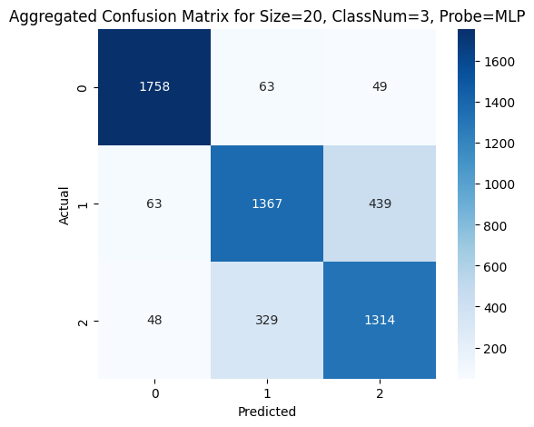

Task 3: ClassNum 9
Location classification: Which part of the face is being touched?

Linear Probe
Size: 3
Train | Validation | Test
Accuracy: 0.7823  Loss: 0.6675 | Accuracy: 0.5360  Loss: 1.7067 | Accuracy: 0.5395  Loss: 1.6856

Precision | Recall | (Macro) F1 Score
0.2793 | 0.2571 | 0.2592

Confusion Matrix:
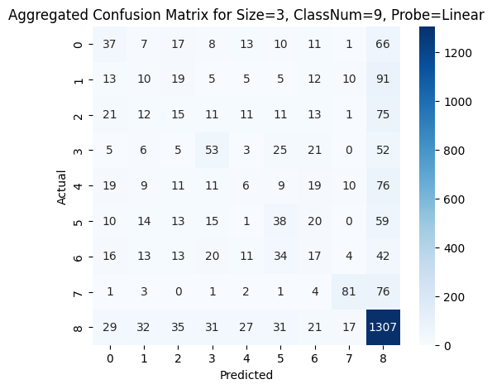

Size: 5
Train | Validation | Test
Accuracy: 0.7589  Loss: 0.7167 | Accuracy: 0.5468  Loss: 1.6346 | Accuracy: 0.5503  Loss: 1.6081

Precision | Recall | (Macro) F1 Score
0.3000 | 0.2767 | 0.2804

Confusion Matrix:
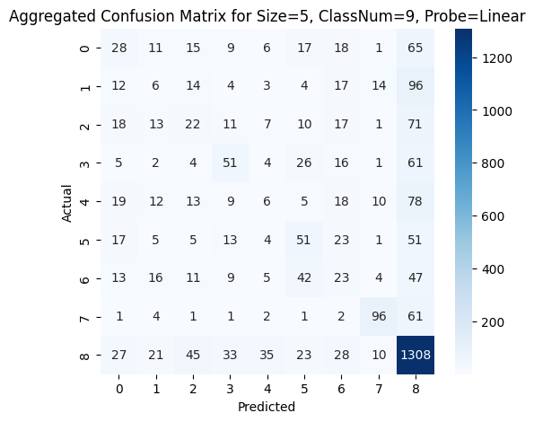

Size: 10
Train | Validation | Test
Accuracy: 0.7032  Loss: 0.8512 | Accuracy: 0.5605  Loss: 1.5114 | Accuracy: 0.5602  Loss: 1.4964

Precision | Recall | (Macro) F1 Score
0.3143 | 0.2766 | 0.2819

Confusion Matrix:
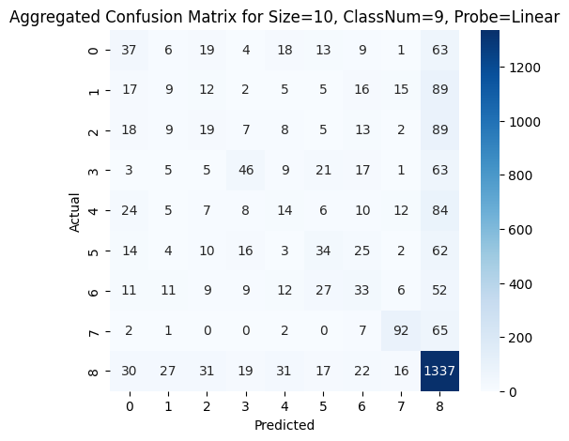

Size: 15
Train | Validation | Test
Accuracy: 0.6967  Loss: 0.8713 | Accuracy: 0.5628  Loss: 1.4615 | Accuracy: 0.5731  Loss: 1.4632

Precision | Recall | (Macro) F1 Score
0.3282 | 0.2914 | 0.2985

Confusion Matrix:
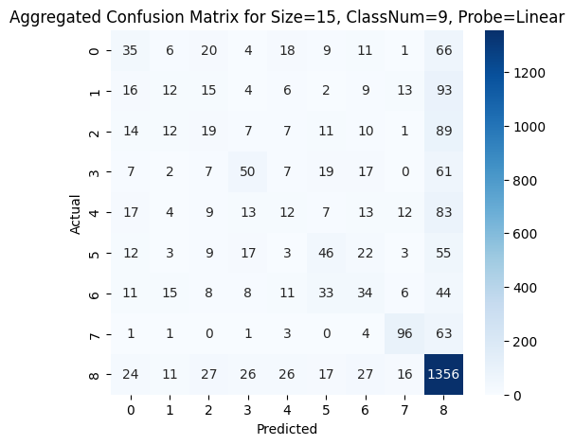

Size: 20
Train | Validation | Test
Accuracy: 0.6925  Loss: 0.8870 | Accuracy: 0.5663  Loss: 1.4552 | Accuracy: 0.5708  Loss: 1.4488

Precision | Recall | (Macro) F1 Score
0.3232 | 0.2882 | 0.2953

Confusion Matrix:
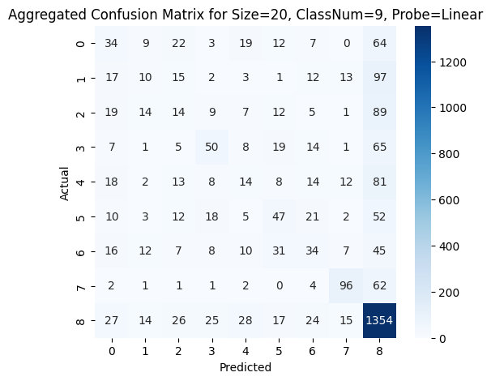

MLP Probe
Size: 3
Train | Validation | Test
Accuracy: 1.0000  Loss: 0.0186 | Accuracy: 0.5426  Loss: 2.4465 | Accuracy: 0.5428  Loss: 2.3999

Precision | Recall | (Macro) F1 Score
0.2827 | 0.2564 | 0.2580

Confusion Matrix:
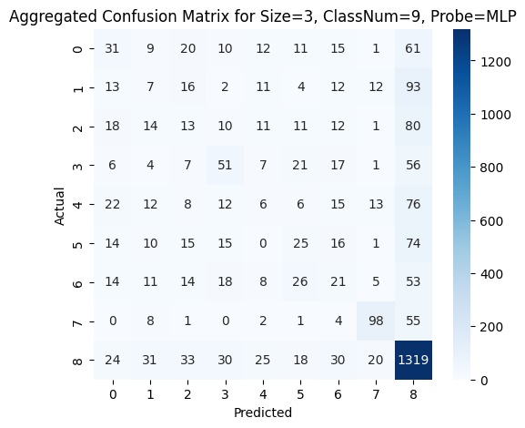

Size: 5
Train | Validation | Test
Accuracy: 1.0000  Loss: 0.0134 | Accuracy: 0.5510  Loss: 2.5388 | Accuracy: 0.5433  Loss: 2.4879

Precision | Recall | (Macro) F1 Score
0.2924 | 0.2659 | 0.2706

Confusion Matrix:
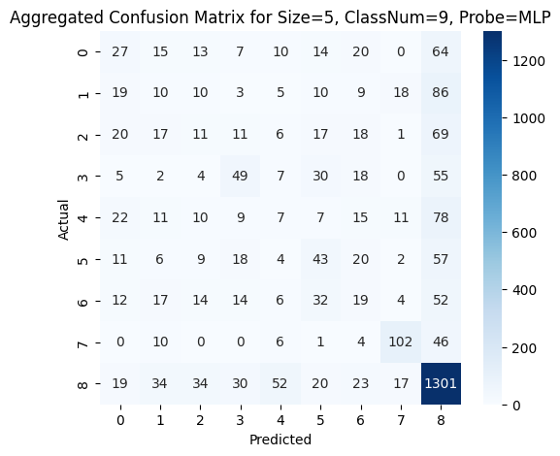

Size: 10
Train | Validation | Test
Accuracy: 1.0000  Loss: 0.0094 | Accuracy: 0.5613  Loss: 2.7210 | Accuracy: 0.5528  Loss: 2.7239

Precision | Recall | (Macro) F1 Score
0.3058 | 0.2860 | 0.2879

Confusion Matrix:
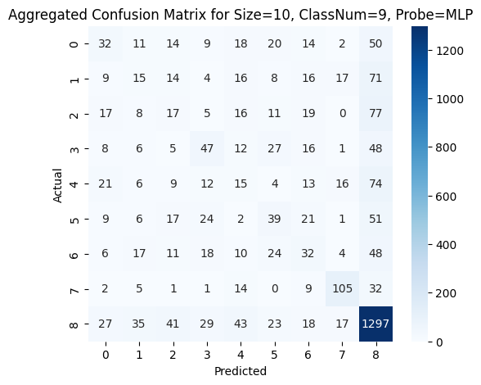

Size: 15
Train | Validation | Test
Accuracy: 1.0000  Loss: 0.0076 | Accuracy: 0.5654  Loss: 2.9003 | Accuracy: 0.5538  Loss: 2.8914

Precision | Recall | (Macro) F1 Score
0.3025 | 0.2797 | 0.2825

Confusion Matrix:
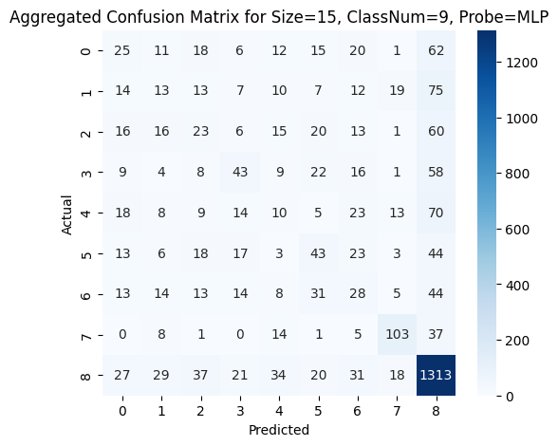

Size: 20
Train | Validation | Test
Accuracy: 1.0000  Loss: 0.0065 | Accuracy: 0.5574  Loss: 3.0910 | Accuracy: 0.5539  Loss: 3.0634

Precision | Recall | (Macro) F1 Score
0.2991 | 0.2825 | 0.2838

Confusion Matrix:
